RESOLUTION NO.__________

RE: CERTIFICATE OF APPROPRIATENESS UNDER THE
PROVISIONS OF THE ACT OF THE PENNSYLVANIA
LEGISLATURE 1961, JUNE 13, P.L. 282 (53
SECTION 8004) AND BETHLEHEM ORDINANCE NO.
3952 AS AMENDED.

WHEREAS, it is proposed to repaint the entrance door and install a sign above the storefront at 420 Main St.

NOW, THEREFORE, BE IT RESOLVED by the Council of the City of Bethlehem that a Certificate of Appropriateness is hereby granted for the proposal.

Sponsored by: (s)

(s)

ADOPTED BY COUNCIL THIS DAY OF

(s)
President of Council

ATTEST:

(s)
City Clerk

HISTORICAL & ARCHITECTURAL REVIEW BOARD

The applicant is proposing to repaint the entrance door and install a sign above the storefront at 420 Main St.
APPLICATION #5:

Central Moravian Church
561 E. Market St.
Bethlehem, PA 18018
OWNER:

__________________________________________________________________

The Board upon motion by Connie Glagola and seconded by Marsha Fritz adopted the proposal that City Council issue a Certificate of Appropriateness for the following:

1. Front door to be painted “Black Swan” and satin nickel hardware will remain.

2. Black backer board to be approximately 1” higher than the reused solid brass
letters.

3. To add a pin stripe projecting above or below the normal height of the other
letters.

4. Pin stripe to be along the top, bottom and sides of the sign board.

5. The motion was unanimously approved.
__________________________________________________________________________

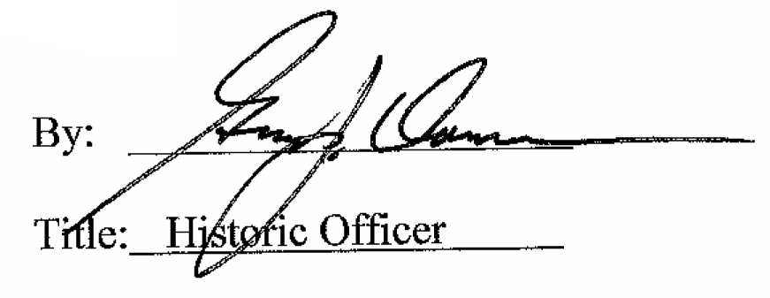

Date of Meeting: July 6, 2016

